Texas Lotto Statistical Analysis and Predictive Modeling
Executive Analytics Report
Prepared By:
Jose Reyes
MS Business Analytics & Artificial Intelligence
University of Texas Rio Grande Valley
May 2026

Executive Summary
This project analyzed historical Texas Lotto winning number data to explore statistical behavior, probability distributions, structural patterns, and predictive modeling capabilities within lottery draw data. The objective was not to predict exact future winning numbers, but rather to evaluate whether historical lottery outcomes contain measurable statistical structure and whether machine learning techniques could identify broader predictive relationships within the dataset.
Exploratory data analysis revealed several recurring structural characteristics across historical draws. Balanced odd/even combinations and balanced high/low number distributions occurred significantly more frequently than extreme patterns such as all odd or all high combinations. Consecutive number pairings were also observed more frequently than commonly assumed, demonstrating that random systems naturally produce clustering and adjacency patterns over time.
A chi-square goodness-of-fit test identified statistically significant deviations from perfect uniformity; however, Monte Carlo simulation demonstrated that historical lotto behavior remained broadly consistent with expected random combinational processes.

Business Objective
The objective of this project was to analyze historical Texas Lotto winning number data to identify statistical patterns, evaluate probability distributions, and explore whether broader structural characteristics of lottery draws contain measurable predictive relationships. The project applied exploratory data analysis, inferential statistics, Monte Carlo simulation, and machine learning techniques to examine the statistical behavior of historical lottery outcomes.

Dataset Overview
The dataset consisted of 3,741 historical Texas Lotto draws containing six winning numbers per draw. After cleaning and preprocessing, only the six winning number columns were retained for analytical purposes. The final dataset contained 22,446 historical winning numbers ranging from 1 to 54.
Additional engineered features included odd/even distributions, high/low distributions, consecutive pair counts, and total draw sums.

Methodology
This project was conducted using Python within a Google Colab environment. Data preprocessing and exploratory analysis were performed using Pandas and NumPy, while visualizations were created using Matplotlib. Statistical hypothesis testing was conducted using SciPy, and machine learning modeling was implemented using Scikit-learn.
The analytical workflow included:
- Data cleaning and preprocessing
- Exploratory data analysis
- Probability distribution analysis
- Chi-square goodness-of-fit testing
- Monte Carlo simulation
- Random Forest classification modeling
- Feature importance evaluation

Exploratory Data Analysis
Exploratory data analysis identified several important structural characteristics within historical lotto draws. Balanced odd/even and high/low combinations occurred substantially more frequently than extreme structural patterns. Consecutive number pairings also appeared more regularly than commonly assumed.
Draw sum analysis revealed an approximately bell-shaped distribution centered around mid-range totals, reflecting the combinational probability structure of six-number lottery systems.
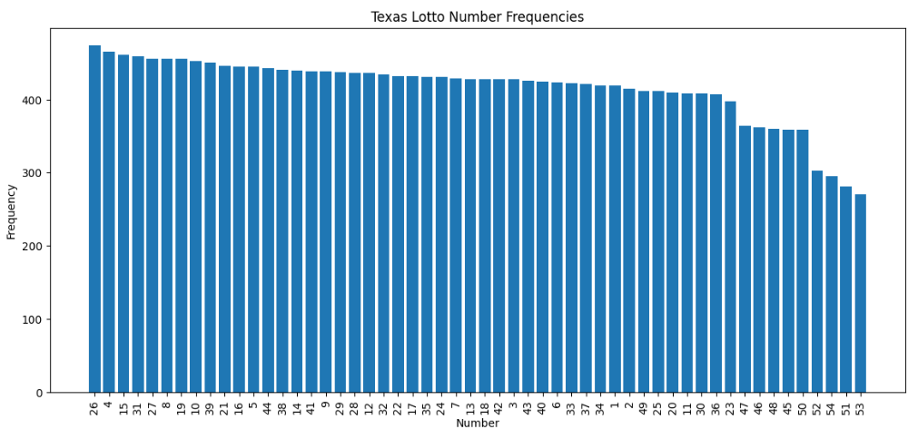
Figure 1: Historical frequency distribution of Texas Lotto winning numbers.
The historical number frequency distribution appears relatively balanced overall, although moderate variation exists across individual numbers. This suggests that while some numbers appeared more frequently over time, the overall distribution remained broadly consistent with expected random fluctuation behavior.
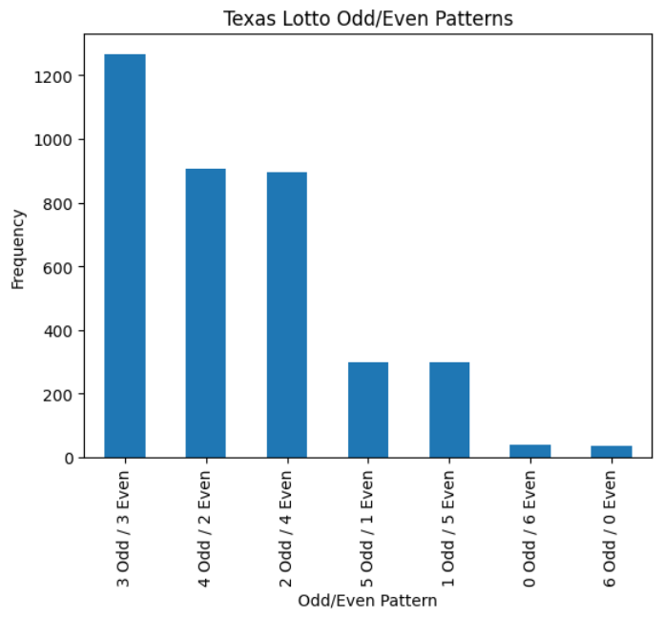
Figure 2: Historical odd versus even number distribution patterns across Texas Lotto draws.
Balanced odd/even combinations occurred substantially more frequently than extreme patterns such as all odd or all even draws. The most common structures consisted of either 3 odd / 3 even or 4 odd / 2 even combinations.
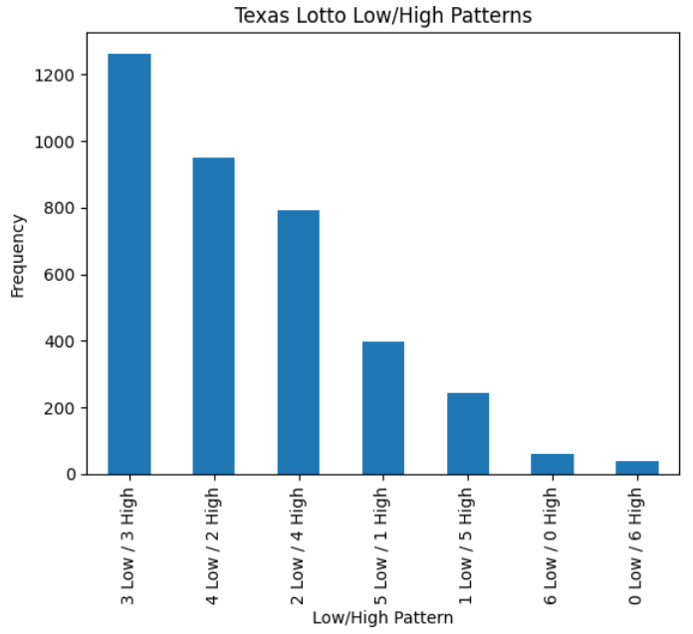
Figure 3: Historical high versus low number distribution patterns across Texas Lotto draws.
Similar to odd/even behavior, balanced high/low number distributions occurred significantly more frequently than highly skewed combinations. This reflects the natural combinational probability structure of six-number lottery systems.

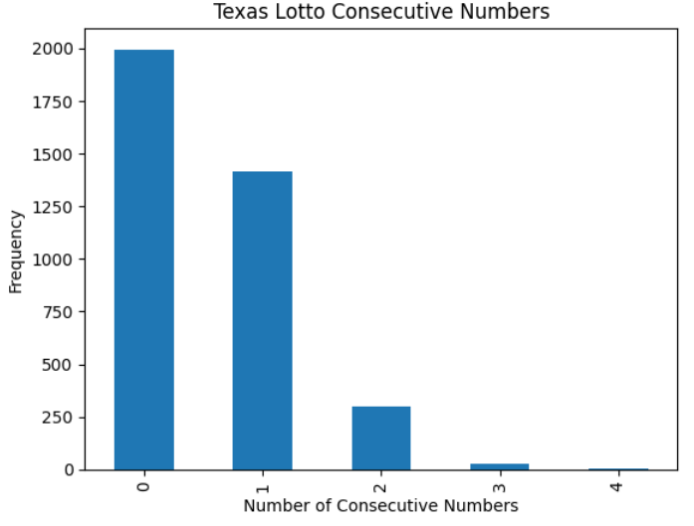
Figure 4: Frequency distribution of consecutive number pairings within historical lotto draws.
Most historical lotto draws contained either zero or one consecutive number pairing. However, multiple consecutive pairings still occur regularly, demonstrating that random systems naturally generate clustering behavior over time.

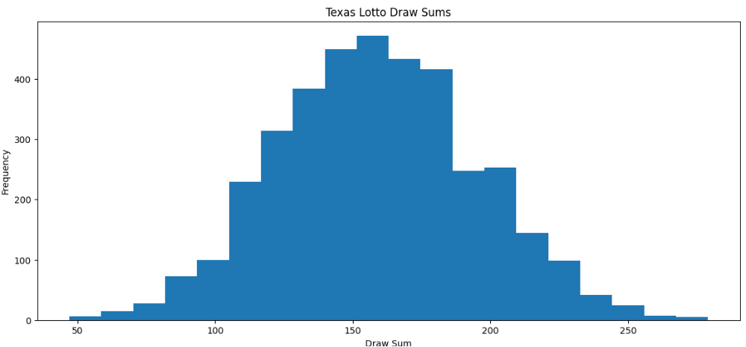
Figure 5: Distribution of historical Texas Lotto draw sums demonstrating approximately normal distribution centered around mid-range totals.
Historical draw sums followed an approximately normal distribution centered around mid-range totals. Extremely low and extremely high draw sums occurred relatively infrequently due to combinational probability constraints.
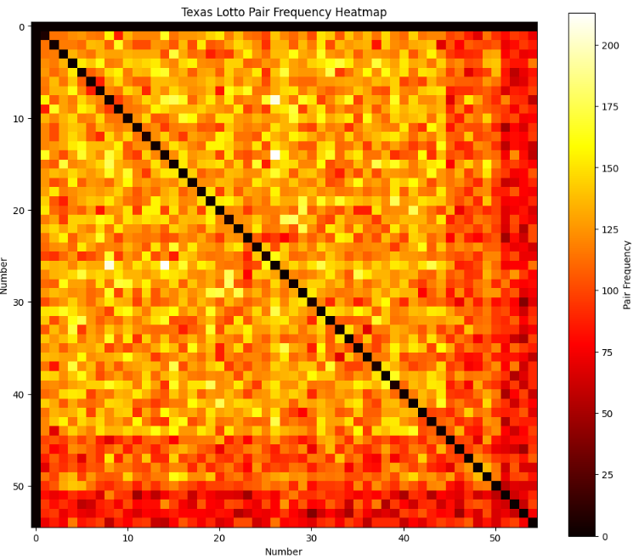
Figure 6: Pair frequency heatmap illustrating historical co-occurrence relationships between Texas Lotto numbers.
The pair frequency heatmap illustrates how frequently number combinations appeared together across historical draws. While some pairings appeared more frequently than others, no deterministic pair structures were identified.

Inferential Statistics
A chi-square goodness-of-fit test was conducted to evaluate whether historical lotto number frequencies followed a perfectly uniform distribution.
The resulting p-value was significantly below the 0.05 significance threshold, indicating statistically significant deviations from perfect uniformity. However, the overall structural behavior remained broadly consistent with expected random variation.
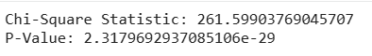
Figure 7: Chi-square goodness-of-fit test results showing statistically significant deviations from perfect uniformity.
The chi-square goodness-of-fit test produced a statistically significant p-value below the 0.05 threshold. This indicates that observed number frequencies differed from a perfectly uniform distribution, although the overall behavior remained broadly consistent with expected random variation.

Monte Carlo Simulation
Monte Carlo simulation was used to generate 10,000 simulated lottery draws for comparison against historical Texas Lotto data.
The simulated draw distributions closely resembled the historical distributions, supporting the interpretation that the historical Texas Lotto system behaves consistently with expected random combinational probability structures.
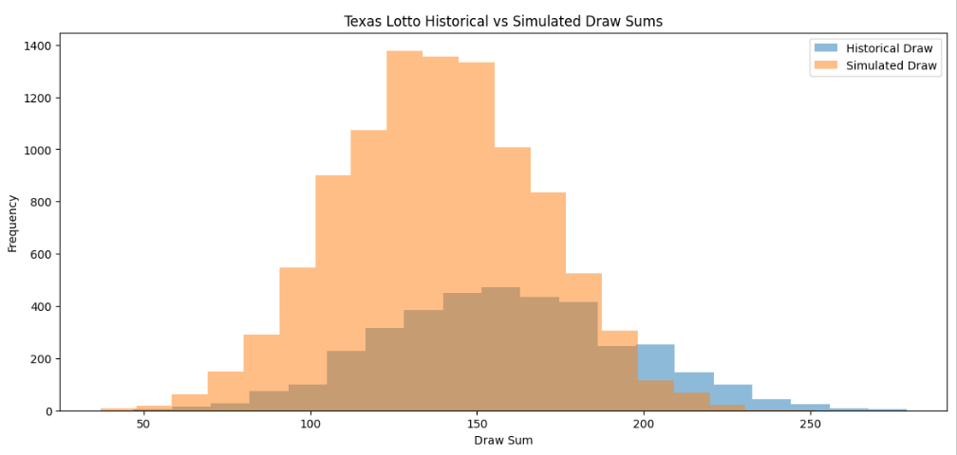
Figure 8: Comparison of historical and simulated lotto draw sum distributions generated through Monte Carlo simulation.
The simulated draw distributions closely resembled the historical lotto distributions, supporting the interpretation that historical Texas Lotto behavior aligns with expected random combinational probability structures.

Machine Learning Modeling
A Random Forest classification model was developed to evaluate whether engineered structural features could predict whether a draw’s total sum would fall above or below the historical median threshold.
The model achieved approximately 83% classification accuracy. Importantly, the model was not used to predict exact winning numbers, but rather to classify broader structural draw characteristics.
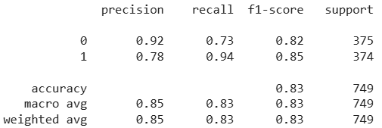
Figure 9: Random Forest classification model performance metrics for high-versus-low draw sum prediction.
The Random Forest classification model achieved approximately 83% overall accuracy when predicting broader draw sum classifications. The model demonstrated strong performance despite the fundamentally random nature of lottery systems.

Feature Importance Analysis
Feature importance analysis revealed that the number of high-value lotto numbers was the dominant predictive factor within the Random Forest model. Odd/even composition and consecutive number patterns contributed comparatively little predictive value.
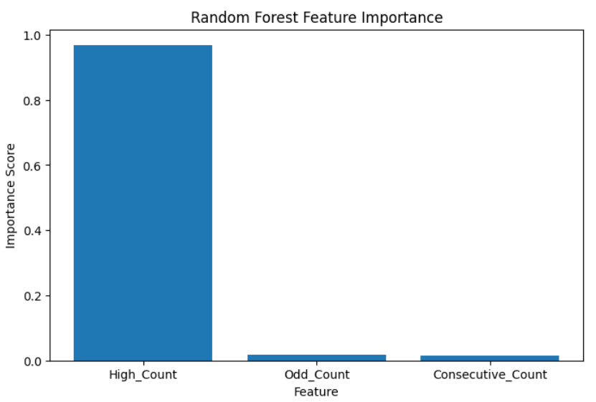
Figure 10: Random Forest feature importance analysis identifying High_Count as the dominant predictive feature.
Feature importance analysis revealed that High_Count was the dominant predictive variable within the classification model. Odd/even composition and consecutive number patterns contributed comparatively little predictive value.

Conclusions
The project demonstrated that historical lottery draws exhibit measurable statistical structure despite the fundamentally random nature of lottery systems. While exact lottery outcomes remain inherently unpredictable, broader structural characteristics demonstrated measurable statistical behavior and limited predictive relationships within engineered machine learning models.

Limitations
Historical number frequency patterns do not imply future predictive capability due to the independent nature of lottery draws.
Several limitations should be considered:
• Lottery systems are fundamentally random processes
• Statistical significance does not necessarily imply practical predictive value
• Machine learning performance depends heavily on engineered structural features rather than exact number prediction

Future Enhancements
Potential future project enhancements include:
• Power BI dashboard deployment
• Advanced clustering analysis
• Neural network experimentation
• Interactive probability simulation tools

